**LAB 3 : Installation of yokto project**

**Group members:-** Shahrukh Padaniya

Rohan Yadav

Swapnil Sewak

**Step 1: Open up the Ubuntu terminal and clone poky from the GitHub repository**

$ git clone <https://git.yoctoproject.org/git/poky>

Here, for this step we have used an alternative step, in which we directly downloaded poky from this link:-

<http://downloads.yoctoproject.org/releases/yocto/yocto-3.2.1/poky-gatesgarth-24.0.1.tar.bz2>

After downloading we extracted the file

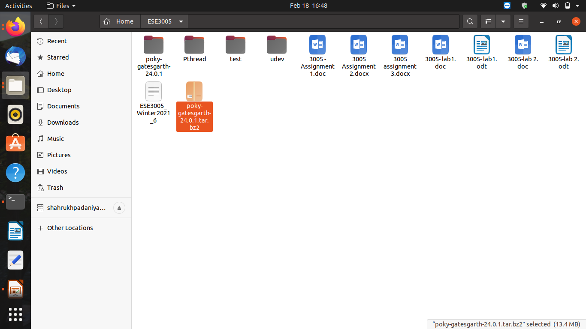

**Step 2: Change directory to Poky and see the list of available components there. What is the result?**

$ cd poky

$ ls

By using the following commands, we can see these files.

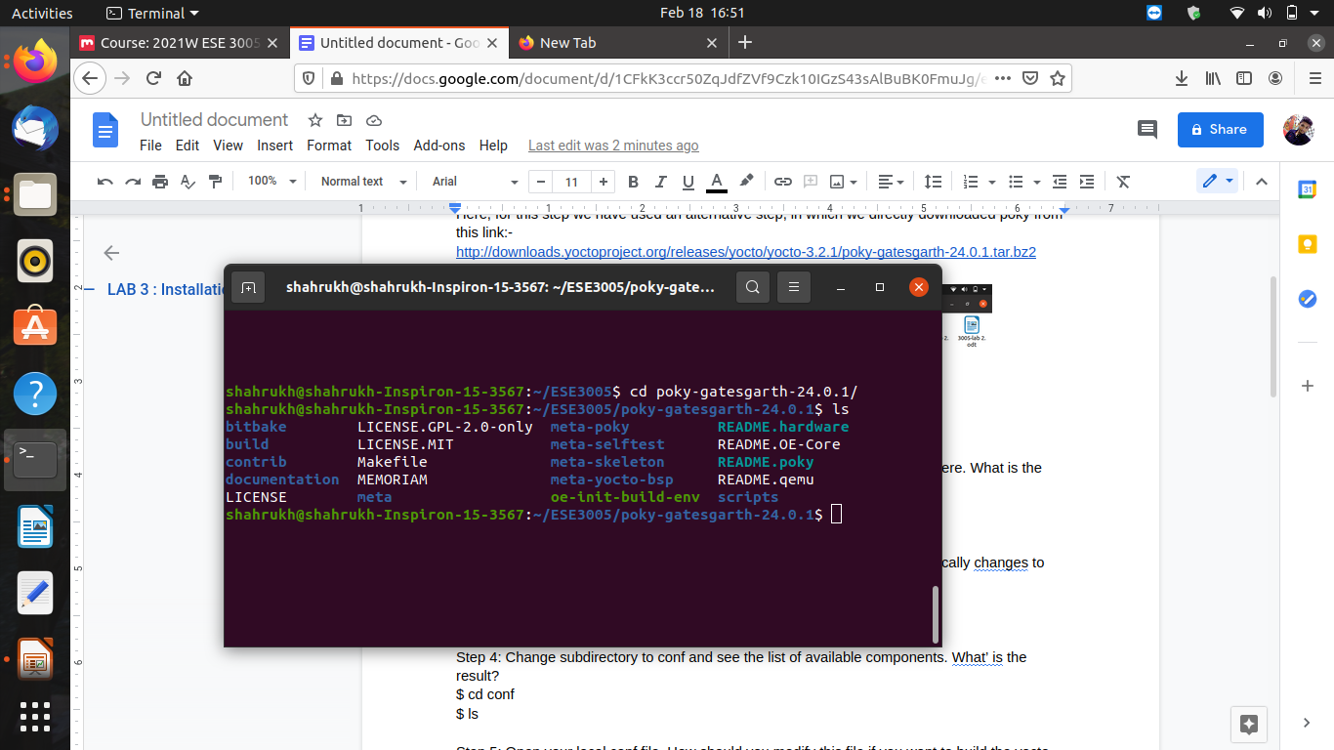

**Step 3: Use source script to set up the environmental variables and automatically change to build subdirectory. See the list of available components. What is the result?**

$ source oe-init-build-env

$ ls

After using these commands, we automatically change to build directory, where we can find files like bitbake-cookerdaemon.log, cache, conf, downloads, state-cache and tasks.

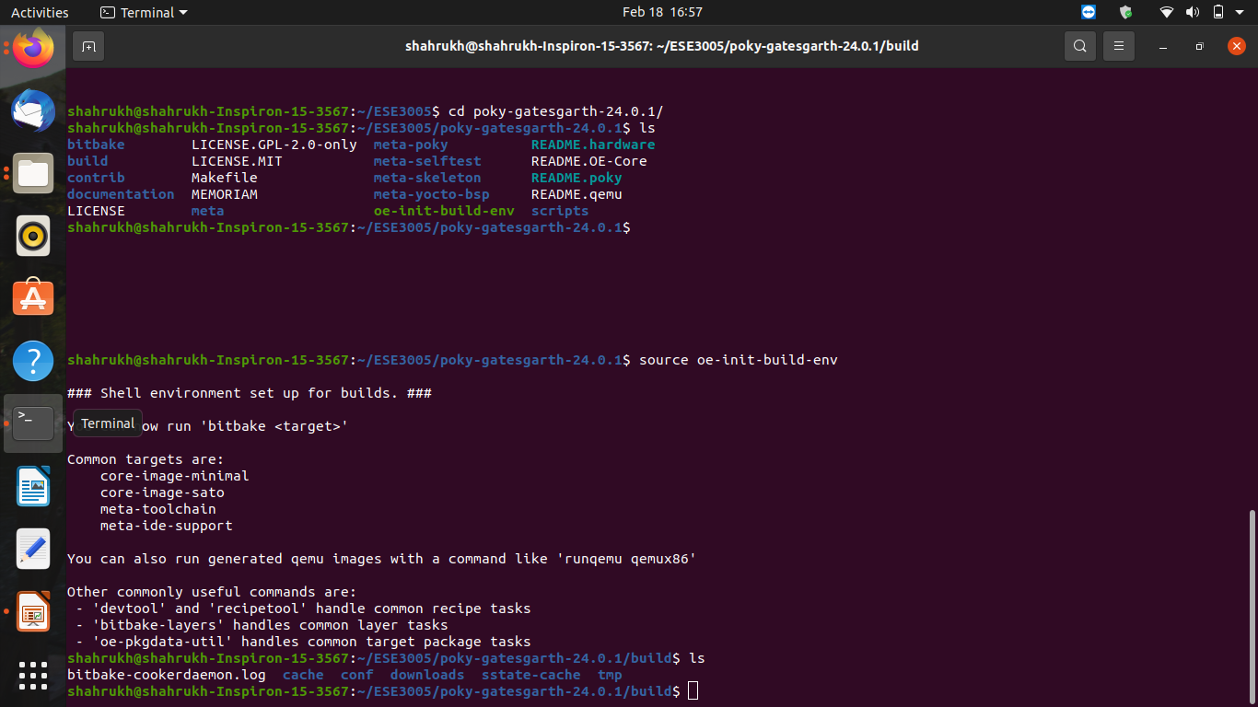

**Step 4: Change subdirectory to conf and see the list of available components. What is the result?**

$ cd conf

$ ls

We can find 3 files after switching to the conf subdirectory.

These files are -

bblayers.conf

local.conf

templateconf.cfg

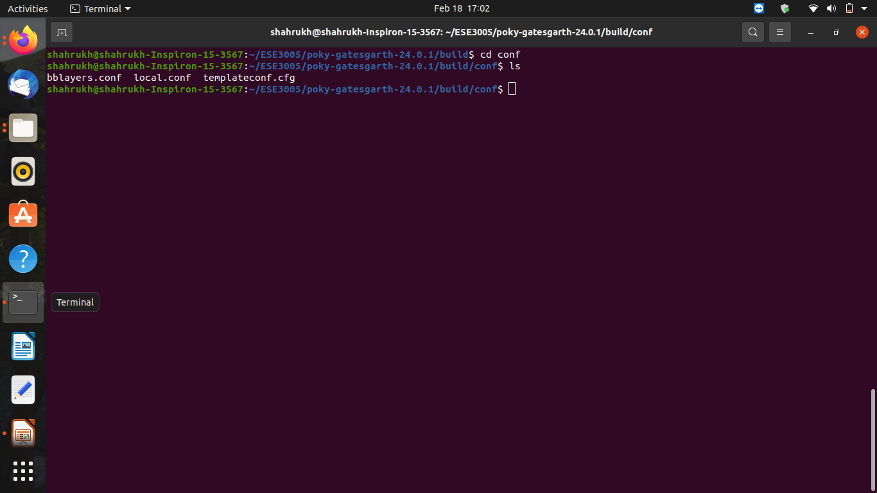

**Step 5: Open your local.conf file. How should you modify this file if you want to build the yocto project on the beagle bone instead of your host machine?**

$ nano local.conf

First we will open the local.conf file by using above command after which we need to uncomment the line shown below (remove # from the specific line). Thus, this will run the project on the beagle bone instead of the host machine.

MACHINE ?= "beaglebone-yocto"

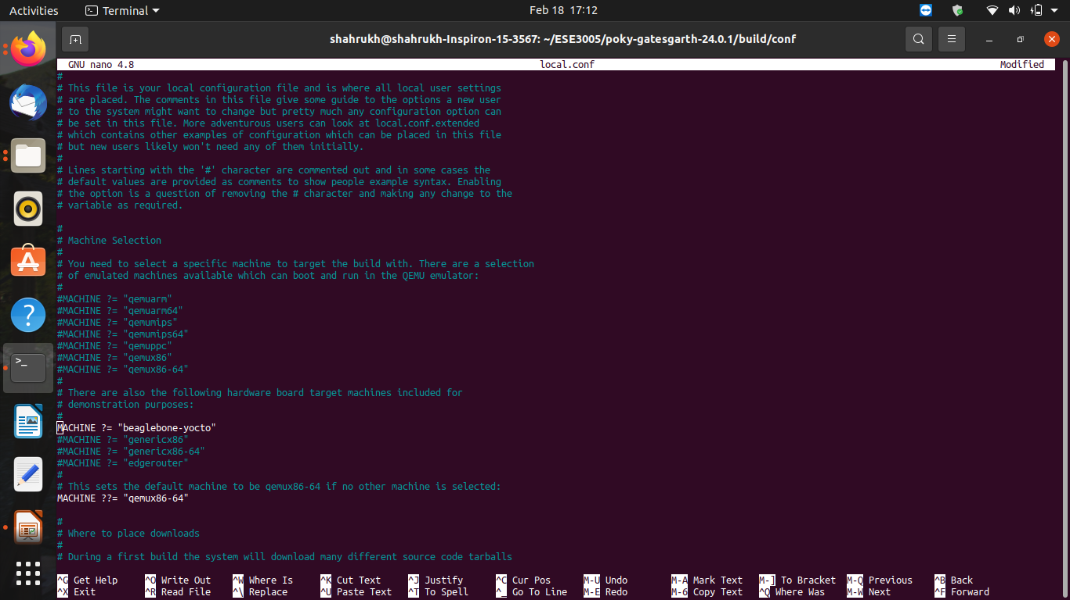

**Step 6: Now exit this editor (how?) and while ensure you are in build subdirectory run bitbake core-image-minimal. This kicks off the build and it takes an amount of time (depending on your CPU and RAM, e.g., if you have a quad-core CPU with 8 GB RAM it should take around 1 hour and half to build your first image of Yocto Project). What’ is the final message?**

$ bitbake core-image-minimal

To exit the nano editor, we need to press ctrl+X which will ask us to save the file if any changes have been made. To save the changes type ‘Y’ else type ‘N’ and press enter.

After running the above command and waiting for around an hour, we got the following result as shown below.

Here, we have run the command again for the second time, so it just took 3sec. So, it provided with the message that task installation: 100%

sstate summary: Wanted 0 Found 0 Missed 0 Current 1087 (0% match, 100% complete)

NOTE: Executing Tasks

NOTE: Tasks Summary: Attempted 3077 tasks of which 3077 didn't need to be rerun and all succeeded.

Thus all 3077 tasks are completed successfully.

